МИНИСТЕРСТВО ОБРАЗОВАНИЯ РЕСПУБЛИКИ БЕЛАРУСЬ

УЧРЕЖДЕНИЕ ОБРАЗОВАНИЯ

“БРЕСТСКИЙ ГОСУДАРСТВЕННЫЙ ТЕХНИЧЕСКИЙ УНИВЕРСИТЕТ”

**ИНТЕЛЕКТУАЛЬНЫЕ ИНФОРМАЦИОННЫЕ ТЕХНОЛОГИИ**

ОТЧЁТ

По лабораторной работе № __

__________________________________________________

Выполнил:

Студент группы ИИ-22

Копанчук Евгений Романович

Проверил__:

_________________

Брест – 2023

**Ход работы**

TASK

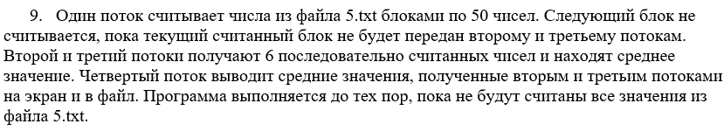

PROGRAM

|  |
| --- |
| void FILL_FILE_WITH_RANDINT_VALUES(std::string file, int left, int right, int amount) {  std::ofstream in(file);  for (int i = 0; i < amount; i++)  in << (int)(left + rand() % right + 1) << ' ';  in.close();  }  std::mutex mtx;  class ThreadMean {  private:  std::string input_file_;  std::string output_file_;  int batch_size_;  int part_size_;  std::vector<int> batch_;  std::queue<int> buf_;  std::queue<double> mean_;  std::queue<int> th_num_;  int batch_number_;  int part_number_;  int last_part_;  bool end_;  public:  ThreadMean(std::string inputfile, std::string outputfile, int batch_size, int part_size) : input_file_(inputfile), output_file_(outputfile), batch_size_(batch_size), part_size_(part_size) {  batch_number_ = 0;  part_number_ = 0;  }  void th_LOADNUMBERS() {  std::ifstream in(input_file_);  if (!in.is_open())  std::cout << "INPUT FILE WASN'T OPEN!" << std::endl;  int num;  while (true) {  if (batch_.size() < batch_size_) {  if (in >> num) batch_.push_back(num);  else break;  } else if (buf_.empty()) {  std::cout << "THREAD WITH #0 SEND BATCH TO THREAD 1 AND 2" << std::endl;  for (int i = 0; i < batch_size_; i++)  buf_.push(batch_[i]);  batch_.clear();  }  }  end_ = true;  in.close();  }  void th_MEANPART(int th) {  while (!end_ || !buf_.empty()) {  std::vector<int> part;  mtx.lock();  while (part.size() < part_size_ && !buf_.empty()) {  part.push_back(buf_.front()); buf_.pop();  }  mtx.unlock();  double mean = 0;  for (int i = 0; i < part.size(); i++) {  mean += part[i];  }  if (mean != 0) {  mtx.lock();  mean_.push(mean / part.size());  th_num_.push(th);  mtx.unlock();  }  }  }  void th_OUTPUT() {  while (!end_ || mean_.size() != 0) {  std::ofstream out(output_file_, std::ios::app);  if (!out.is_open())  std::cout << "OUTPUT FILE WASN'T OPEN!" << std::endl;  for (int i = 0; i < mean_.size(); i++) {  std::cout << "THREAD WITH #" << th_num_.front() << " CALC MEAN: " << mean_.front() << std::endl;  out << mean_.front() << ' '; mean_.pop(); th_num_.pop();  }  }  }  };  int main() {  srand(time(NULL));  std::string input = "input.txt";  std::string output = "output.txt";  int batch_size = 50;  int part_size = 6;  FILL_FILE_WITH_RANDINT_VALUES(input, 0, 100, 10009);  ThreadMean th_mean(input, output, batch_size, part_size);  std::thread th1(&ThreadMean::th_LOADNUMBERS, &th_mean);  std::thread th2(&ThreadMean::th_MEANPART, &th_mean, 1);  std::thread th3(&ThreadMean::th_MEANPART, &th_mean, 2);  std::thread th4(&ThreadMean::th_OUTPUT, &th_mean);  th1.join(); th2.join(); th3.join(); th4.join();  } |

OUTPUT

|  |
| --- |
|  |